SmartPlant 3D v7
Orthographic Drawings Extraction User Training

Table of Contents
Overview 1
Setting up Space Folders in WSE 2
Volume Drawings Workflow 3
A. Creating and Adding Surface Style Rules 3
B. Adding Piping Plan Drawing 5
C. Placing the Drawing Volumes 5
D. Updating the documents 9
Microstation 3D DGN Workflow 10
Setting Drawing Properties 12
Search Folders 13
Placing manual annotation 16
A. Manual labeling 16
B. Dimensioning 17
C. User Text 18

Overview
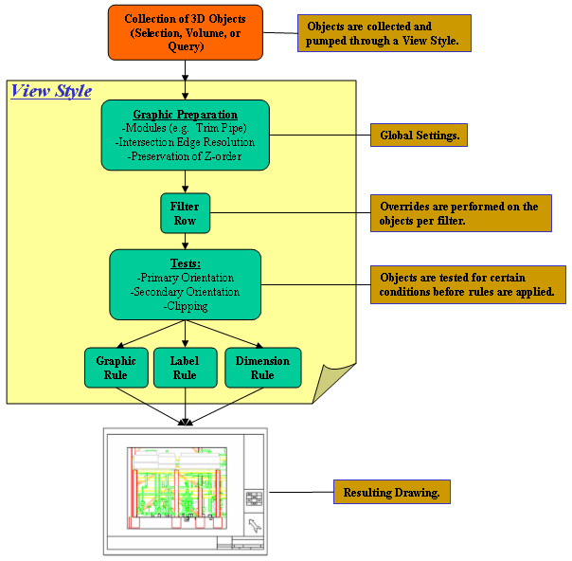

Setting up Space Folders in WSE
- In SP3D, on the menu bar, select Task > Space Management.
- While in Space Management, on the far right side of the screen you will find the Workspace Explorer console. On the Workspace Explorer console, select the “Space” tab.
- On the vertical tool bar on the left side of the screen, select the “Create Space Folder” button , which is the second button from the top.
- When this option is activated, you should see the following on the active ribbon bar:
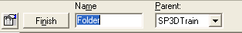
- In the text box labeled “Name”, type in “GA Drawings” and select the Finish button. This will place the space folder “GA Drawings” as a child folder to the parent folder “SP3DTrain”. Notice when you select finish, this places this folder under the “SP3DTrain” folder in the Workspace Explorer on the Space tab.
- With this command still active, on the ribbon bar, change the Parent folder to “GA Drawings” by dropping down the select list and choosing “More”. This will show you all the folders in the hierarchy on the “Space” tab of Workspace Explorer.
- With “GA Drawings” selected as the Parent folder, in the “Name” Text box, type “U01 and U02” and select the Finish button. Notice now that the folder “U01 and U02” has been placed under the folder “GA Drawings”.
- Likewise, create two more folders under “U01 and U02”. Name the first one “Drawing Volumes” and the second “Snapshot”.
- Once you have created the folders needed, you can either right click in the modeling workspace or select the “Select” tool on the vertical tool bar to exit the command.

Volume Drawings Workflow

A. Creating and Adding Surface Style Rules
Creating surface style rules enables you to change the look and feel of the objects the rules are applied to. Currently there is no rule applied to Drawing volumes, therefore the volume will display as solid gray. To create a new surface style rule to be applied to Drawing volumes, do the following steps.
- If you are not already in the Space Management Task, in SP3D, on the menu bar, select Task > Space Management.
- While in Space Management, select Format > Surface Style Rules from the menu bar. The following dialog will appear:
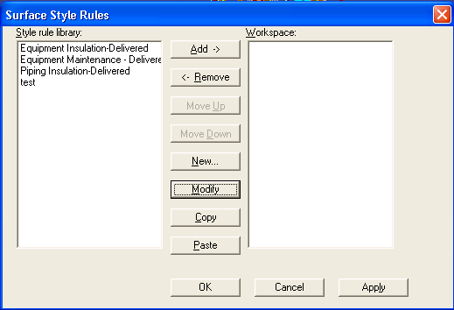
- Since we have no surface style rule for Volumes, we will need to create one. To do so, select the “New” button located in the center of this dialog box.
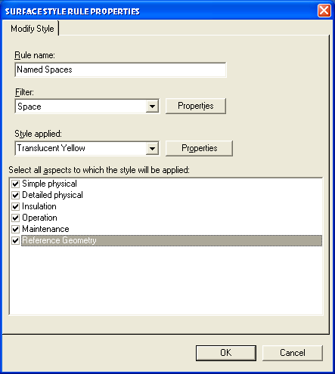
- In the “Rule Name” text box, type in “Named Spaces”.
- For the “Filter”, drop down the select list and choose “More”. This will open the “Select Filter” dialog where you will select: Catalog Filters > Default Filters > SP3D Object Filters > Object Types > Space (filter icon, not the folder) and click OK.
- Next you will apply the style applied to these volumes. Drop down the “Style applied” select list and select the “Translucent Yellow” style. Click OK to complete the creation of this Surface style rule. If the style rule already exists, modify it to the above parameters
- Notice now the new Style you created named “Named Spaces” in the Style rule Library on the left side of the Surface Style Rules dialog.
- To apply this newly created style, select the style from the left side of the dialog and click the “Add ->” button to move this style into the Workspace side. Highlight Named Spaces there and click Apply, then OK (failure to “Apply” will result in this style not getting used).

B. Adding Piping Plan Drawing
- Define workspace to “U01 & U02” from Training Filters.
- Switch to Drawings and Reports task
- Right mouse on the “SP3DTrain” Plant and select New…
- In the Add Component Dialog, from the General tab, select “Folder” and click OK.
- Right click on the newly created folder and select “Rename” and rename it to “GA Drawings”
- Right mouse on the “GA Drawings” folder and select New…
- In the Add Component Dialog, from the “Piping” tab, select “Imperial_Piping Plan”, and click OK.

C. Placing the Drawing Volumes
a. Place Drawing Volume by View
- Switch to the Space Management task.
- Open two graphics Windows and orient them to “Looking Plan” and “Looking North”. Hint: Use Common Views command
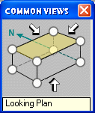
- Start pin-point.
- Start the Place “Drawing Volume by View” command 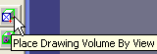
- In the ribbon bar, select “Piping Plan” for the Drawing Type. Drop down the select list for the Space Folder property and select the “Drawing Volumes” folder created earlier (may need to use more.. Database).
- In the pin-point toolbar, enter coordinates: E: 72’, N -2’, El –3’
- Click in a graphic view once. Next, the prompt will say: Place Second Pt
- Enter Elevation El 31’
- Click a view to place the volume.
- Place a second volume by entering pinpoint coordinates E: 72’, N 32’ 6”. El –3’ as prompt reads Place First Point
- Click in a graphic view.
- Enter Elevation EL 31’
- Click to place the second volume adjacent to the first one.
- Switch to the space tab of the Workspace Explorer to see that the two drawing volumes are created under the hierarchy of the drawing folders.
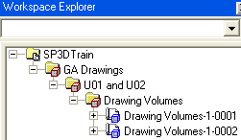
b. Place Volume by Selection
- Set a Window orientation to Isometric and close up to the frame shown in step 4 below
- Start the Place Drawing Volume by Selection command 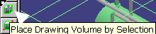
- In the ribbon bar, drop down the select list for Drawing Type and select
“More”. Navigate to the “Piping Plan” component and select OK.
Likewise, for the Space Folder property, drop down the select list for the
Space Folder property and select the “Drawing Volumes” folder from the
hierarchy and Click OK.
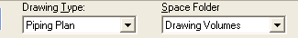
- Using the mouse pointer, select the objects shown in the figure below.
Notice as you click objects, the volume expands to include those objects.
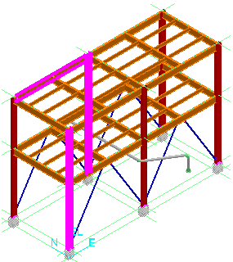
- After you have created the area for the volume, click Finish.
- Switch to the space tab of the Workspace Explorer to see that the three drawing volumes are created under the hierarchy of the drawing folders.

c. Place Volume by Two Points
- Fit all graphics in at least one Window
- In Space Management, start the Place Drawing Volume by Two Points command.
    - 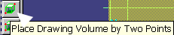
- In the ribbon bar, drop down the select list for Drawing Type and select
“More”. Navigate to the “Piping Plan” component and select OK.
Likewise, for the Space Folder property, drop down the select list for the
Space Folder property and select the “Drawing Volumes” folder from the
hierarchy and Click OK.
- Using pinpoint, for your first point enter E 50’, N 9’, EL 2’
- Click in the workspace to place your first point.
- To place your second point, using pinpoint, enter E 72’, N 26’ EL 30’ and click in the workspace to place the second point, which will create the volume.
- Switch to the space tab of the workspace explorer to see that the four drawing volumes are created under the hierarchy of the drawing folders.
d. Place Volume by Four Points
- In Space Management, start the Place Drawing Volume by Four Points command.
- 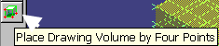
- In the ribbon bar, drop down the select list for Drawing Type and select
“More”. Navigate to the “Piping Plan” component and select OK.
Likewise, for the Space Folder property, drop down the select list for the
Space Folder property and select the “Drawing Volumes” folder from the
hierarchy and Click OK.
- Using pinpoint, for your first point enter E 72’, N 58’, EL 0’. This point will define your starting point.
- Click in the workspace to place your first point
- For your second point, enter E 72’, N 2’, EL 0’. This point will define your X-AXIS, based on the starting point to this point.
- Click in the workspace to place your second point.
- To place your third point, unlock the coordinates by clicking on the lock buttons beside the coordinate values and enter E 112’, N 2’, EL 0’. This point will define your Y-AXIS, based on the second point you placed to this point.
- Click in the workspace to place your third point.
- To place your fourth point, unlock the Elevation coordinate by clicking on the lock button beside the coordinate value and enter EL 30.5’
- Click in the workspace to place your fourth point. Notice when you click in the workspace, your volume is created.
- The five drawing volumes are created under the hierarchy of the drawing volumes folders

D. Updating the documents
- Switch to the Drawings and Reports task.
- Expand the tree to GA Drawings and right mouse click on Piping Plan.
- Select Create Drawings.
- Five drawings are created, select the first one, right mouse click and select “Update Now”. This takes about a minute.
- Open drawing to view it (double click).
- Continue by updating the remaining drawings and viewing them.

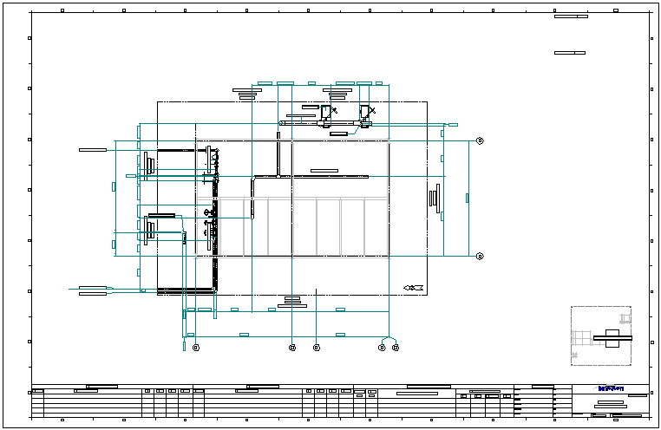

Microstation 3D DGN Workflow
- Right-click on GA Drawings and select New..
- From the Add component dialog, select Microstation 3D DGN from the General tab
- Right-click on New 3D DGN Drawings and click Setup…
- Verify that the style is set to 3D DGN (NOT LISTED AS A DEF STYLE..)
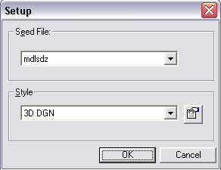
- Switch to the Space Management task
- Start the Place Drawing Volume by Selection command
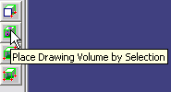
- On the ribbon bar, pick ‘New 3D DGN Drawings’ in the Drawing Type field and click OK.
- Select the slab, one of the top beams and one of the pumps as shown
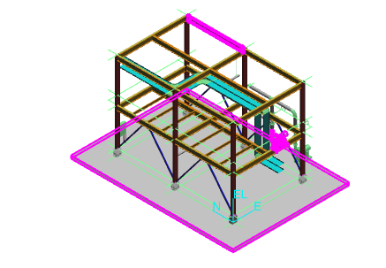
- Click Finish to create the volume
- Switch to Drawings and Reports task, create drawing and update. Wait while MicroStation is opened and closed.
- Double-click the drawing to open and view the output 3D DGN file.

Setting Drawing Properties
Exercise:
- Select the Plant parent level in the hierarchy, right click, and select “Properties”. Add values for the following attributes, Click the field to update and type:
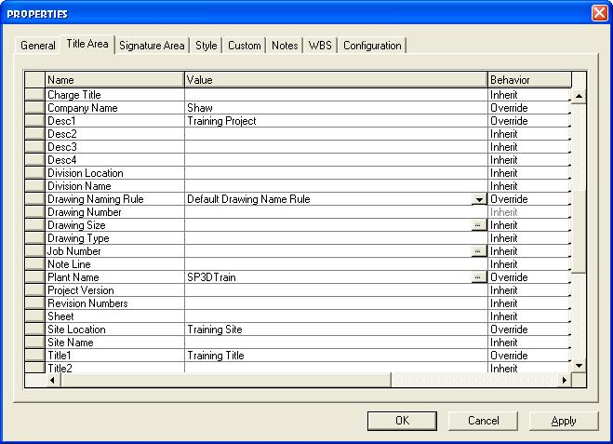
- OK the form to save the Plant level attributes.
- Right click on the “GA Drawings” folder, select “Properties” and review the Title Area attributes. Note that the Plant level attribute values have been applied to the GA Drawings folder.
- Edit the Title 2 text for GA Drawings properties to read ‘GA Drawings Level Data’
- OK the form and exit.
- Reselect the Plant root level, right click, and select “Properties”. Change the Title 1 attribute string to read “Plant Level Data”. OK and exit the form.
- Select the GA Drawings folder, right click, select “Properties”. Note that the Plant Level attribute for Title 1 has automatically changed to “Plant Level Data” in Drawings GA as changed above.
- Similar attribute behavior is seen for all plant folders, snap-ins, and items (drawings, reports, or isos).

Search Folders
The “Search Folder” component allows you to search for documents based on common properties such as out-of-date status, approval, or documents that have been published to a certain contract in integrated environments. You can create a Search Folder component in any folder in the Management Console. After running the query defined for a Search Folder, you can perform such tasks as Update or Publish as if you were working from the actual owning component location for the documents.
In this lab, we will create a Search Folder that will return all drawings that are out-of-date.
- While in the Drawings and Reports Task, Right-Click on the root component “SP3D Train”, then in the drop-down list Select “New”. 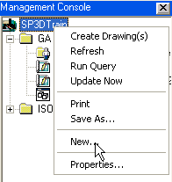
- From the “Add Component” dialog, on the General Tab, Select “Search Folder”, and Click OK.
- This will add a component called “New Search Folder” into the Drawings and Reports hierarchy. Right-Click on “New Search Folder” and Select “Setup”. 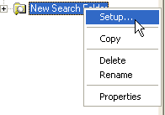
- In the Setup dialog, for the “Filter” property, choose “More”. This will bring up the Select Filter dialog. Click on the “Plant Filters” folder and select the “New Filter (Simple or Asking)” button on the horizontal toolbar.
- On the “New Filter Properties” dialog, type in “Search for Out-of-Date Volumes” for the “Name” property.
- Click on the “Properties” tab in the filter definition dialog.
- For the “Property” field, drop down the select list and choose “More”. This will open the “Select Properties” dialog.
- For the “Object type used as the basis for the property identification” property, drop down the select list and choose “More”. This will open the “Select Object type” dialog. Select the “Drawing Sheets” folder as follows and click OK:
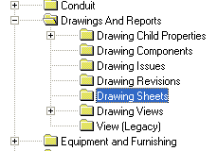
- With the “Relationship” property set to “Direct Property of Object Type” and the “Display properties in this category” set to “Standard”, scroll to the bottom of the list at the bottom of this dialog and select the “UpToDate” property, as follows, and click OK:
- 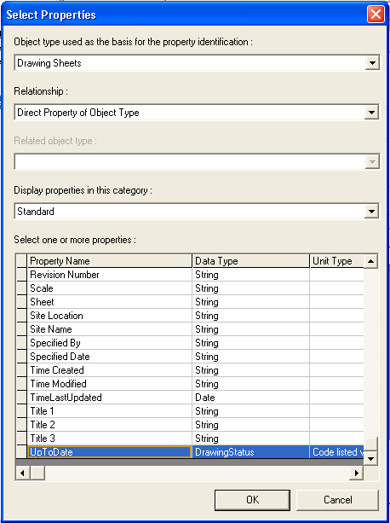
- For the “Operator” property, drop down the select list and choose “=”.
- For the “Value” property, drop down the select list and choose “Border Out Of Date”. The selection should look as follows:
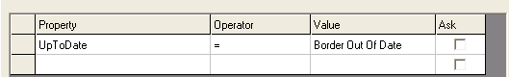
- Click OK to save and exit the filter definition.
- On the “Select Filter” dialog, select the filter that was just created and click OK, which will save and close out this dialog.
- On the Setup dialog, set the “Start From:” property to “SP3DTrain”. Click OK to save and exit this dialog.
- In the Management Console, right click on the “New Search Folder” and select “Run Query”.
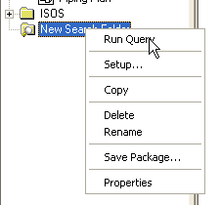
- This will return the drawings that meet the criteria in the filter definition.

Placing manual annotation

A. Manual labeling
- Select the DrawingNumber1 from the Snapshot drawing type, right click and select Edit.
- Zoom into the pumps in the plan view
- Select the place a label command
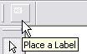
- Select one of the pumps
- From the pick list of labels, pick the Name_Rect_CA_JL label as shown
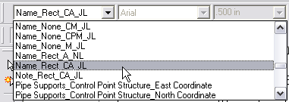
- Make sure the ‘As Drawn’ checkbox in the ribbon bar is checked.
- A label appears on your cursor, click in the sheet to place it where desired.
- Now select the other pump and label it.
- Right-click to exit the labeling command

B. Dimensioning
- Click the Dimension button in the main toolbar to open the dimensioning toolbar.
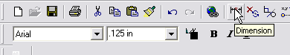
- Dock the dimensioning toolbar to the top of the screen and select the Distance between command
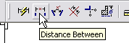
- Select two gridlines in the plan view by clicking them in succession as shown. A dimension appears on your cursor.
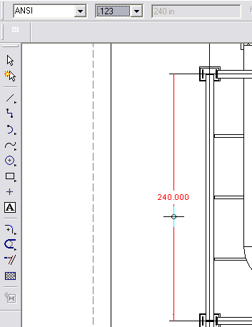
- Click to place the dimension where desired.

C. User Text
- Select Tools – Layers
- In the layer toolbar, key in UserText and press Enter. This will create a new layer named UserText and make it active
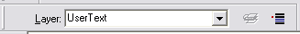
- Using the text command on the vertical toolbar, enter some text, e.g. the name of the view and place it under the view.
- Save and exit the drawing.

All of the manually placed text or graphic annotation on layers whose name starts with the letters ‘User’ is saved. All labels and dimensions are saved through updates.

